

School of Physics, Engineering and Technology

Stage 2 Engineering Project: Maze Solving Robot

Background Information

Introduction

Welcome to the second year project.

The aim of this project is to design a small autonomous robot which can find its way to the centre of a walled maze in the fastest possible time.
At the moment you have the maze available to you!

The project process should be familiar to you, it may look something like this:

- Understand and specify to objective,
- Research relevant information,
- Break down the overall objective into manageable stages,
- Develop ideas,

- Identify parts required,
- Make or source the parts,

- Design the required software,
- Assemble and test prototypes,
- Refine design and re-test,
- Complete the solution ready to race.

There is a lot of information available for this project and your first task is to find what is most helpful to you. The secrets of the fast robots are closely guarded so work on a staged approach building from one stage to the next. You will encounter unforeseen challenges along the way and your approach to managing these should be documented.
Assessment of your project is about successful stages leading towards the final outcome.

As this is the stage 2 project there is still some help available to you. An evaluation robot is provided for you for the first few weeks. The robot is the 3Pi robot from Pololu. There is a lot of information available for this and you should use this at an early stage to give you ideas on both hardware and understanding of software. You should quickly be able to program this robot for line following and line maze solving. Line following requires a different approach to wall following but should give you many ideas to develop.
Using this background knowledge you will design and build your own robot bearing in mind the budgetary constraints of the competition. Many useful parts for prototyping will be available. Where you require additional parts you will have to negotiate these with your supervisor and the project leader. Be aware that there will be a lead time on parts ordering
The following pages will give you background information on the overall objective and information on some of the components that may be useful to you. The intention is that this will get you started and should not be taken as a definitive guide.
At the end of the document is a list of Rules for International Micromouse Competitions, this is the ultimate goal.

Enjoy!

Micromouse Competition

Abstract

The Micromouse competition is an annual contest hosted by the Institute of Electrical and Electronics Engineers (IEEE). A small autonomous mobile robot, called a Micromouse, must navigate through an unknown maze and locate the center. The Micromice are judged by the time it takes them to find the center. The robot that makes the fastest timed run from the start to the center of the maze is declared the winner of the competition.

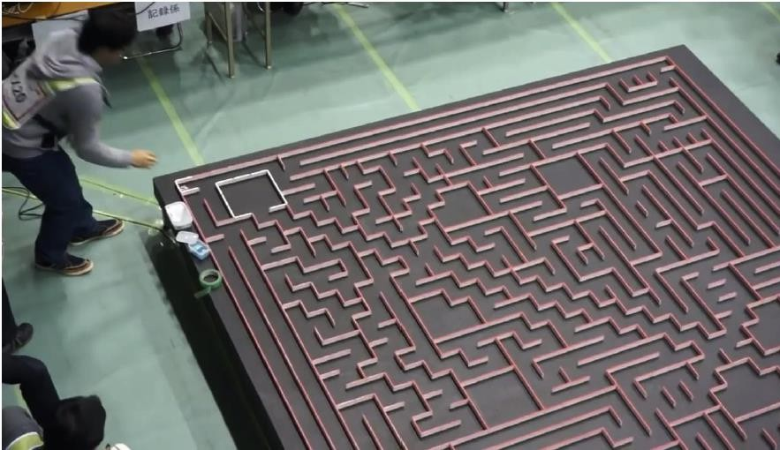

Figure 1: Example maze used for maze solving robot competitions

Figure 1 shows an example of the type of wall-bound maze a small robot should be able to self-navigate by learning about its surroundings using sensor data in an intelligent algorithmic program.

The Micromouse encompasses a vast range of engineering fields which can be divided into two categories: hardware and software. With the technology available for robotics today, the Micromouse competition has become increasingly more complex since its inception several decades ago. Advanced microcontrollers and microprocessors have transferred much of the complex logic that used to be implemented in hardware to software. The hardware is responsible for perceiving the surrounding environment and moving about the maze. The software, on the other hand, is responsible for navigating the maze, interpreting the environment, and sending control signals to the different hardware subcomponents.

The hardware has been further subdivided into components of a more manageable size. The different hardware components are: power, sensors, control, and drive train. The power system consists of the battery pack and voltage regulation scheme in the circuit. The sensors are the means through which the Micromouse detects walls and traverses the maze with proper alignment in the center of a pathway. The drive train includes the motors and motor controllers, which produce the motion of the robot. Finally, the control unit is responsible for controlling each of the other components. Each of these parts needs to go through a thorough process of design, analysis, and component selection.

The focus of the software has been on the selection and development of algorithms for solving mazes since finding the center of the maze is the primary goal of the Micromouse. Some example algorithms are: Wall Following, Depth- First Search, and Flood-Fill. Wall-Following is a trivial algorithm that is usually unsuccessful if implemented for IEEE Micromouse mazes, while Depth-First Search is an intuitive algorithm that also proves to be ineffective due to wasted time searching the entire maze. As such, the Flood-Fill algorithm and its many variations result in the best searching techniques.

Problem Statement

The main objective of this project is to design and construct an autonomous robot to compete in the annual IEEE Micromouse competition. The design of the Micromouse is subject to several constraints, as follows:
- Cost - The total bill of materials must be under £100.
- Size - The robot must be small enough to fit within a maze cell that is 16 cm x 16 cm.
There is no height restriction.
- Time - The robot is limited to a period of 15 minutes, in which it must solve the maze and make as many speed runs to the center as possible.
- Communication - The robot must be fully autonomous, and no outside communication is allowed.
- Maze Integrity - The robot cannot cause damage to the maze or leave behind any debris in its path.

The significance of the project is that research in the field of robotics has a variety of far-reaching social implications, including advancements in biomedical engineering (e.g., miniature robots used to perform medical tests or aid in surgery), automation of tasks unsuitable for human beings, rescue operations, domestic applications, etc.

Project Goal
To develop teamwork skills in a group project setting. You will work in groups on a system involving the development of a maze-solving autonomous robot. You will gain hands-on experience with designing, fabricating and testing a robot chassis, sensor and actuator hardware using 3D printing, laser cutting, and other rapid-prototyping techniques. You will also gain hands-on experience designing systems dependent on programs written for microcontrollers and maze solving algorithms capable of determining the optimal path to the centre of a maze.

History of the IEEE Micromouse

The micromouse contest was created by former IEEE Spectrum Editor in Chief Donald Christiansen. 'The winner of this rat race is the mouse with the best ability to nose its way through a maze' starts this May 25, 1979 Peninsula Times article which documents two of the competitors in the 1st Amazing Micromouse Contest.


Figure 2: Article about a winning robot in an early micromouse competition
In 1977, the Institute of Electrical and Electronics Engineer’s Spectrum Magazine first introduced the idea of the autonomous Micromouse robot as a maze solving device. Soon after, the first IEEE Amazing Micromouse Maze Contest was held in New York in June 1979. Out of over 6000 entries received, fifteen Micromice competed, from which the eventual winner was Moonlight Flash, a non-intelligent wall follower mouse. Since the aim of the competition was to invite “intelligent” mice that utilize microprocessor technology, Moonlight Flash entered based on a loophole in the contest rules. Competition rules were subsequently amended, with mazes being specifically designed to prevent wall-following strategies from succeeding (“The amazing”).
Popularity of the Micromouse grew from there, and competitions were soon held all around the world. The first European Competition took place in London in 1980, and the first World Micromouse Competition, open to contestants from across Europe and the United States, was held in Tsubuka, Japan in August 1985. From the early 1990s, Micromouse clubs started to appear in schools and universities around the world (“History”). The IEEE Micromouse Competition now enjoys great popularity among undergraduate and graduate student organizations of computer and electrical engineering departments everywhere.
Micromice have undergone an astounding metamorphosis over the years. Early Micromice were far less technologically and electronically advanced compared to those of today. Moonlight Flash, the winner in 1979, was a crude mechanical mouse that simply employed a feeler along the walls to navigate its way to the goal (“The Micromouse”). Moreover, several of the other mice at the competition did not include microprocessors in their design, instead opting to use simple IC logic. The top motor speed at that competition was 52 centimeters per second from a mouse using then-sophisticated stepper motors for its motion (“The amazing”).

In contrast, today’s Micromice are extremely evolved, electronically refined robots. Current microprocessor technologies allow the mice to perform computations not conceivable twenty-five years ago. As a result, the robots can be programmed to use more sophisticated algorithms to find the center of the maze. Motors, sensors, integrated circuits and other components have greatly improved features to assist the robot designer. Depending on the maze design, mice can now run at speeds of up to 3 meters per second (“Micromouse”). Overall, Micromice are now smaller, faster, and smarter than their earlier counterparts.

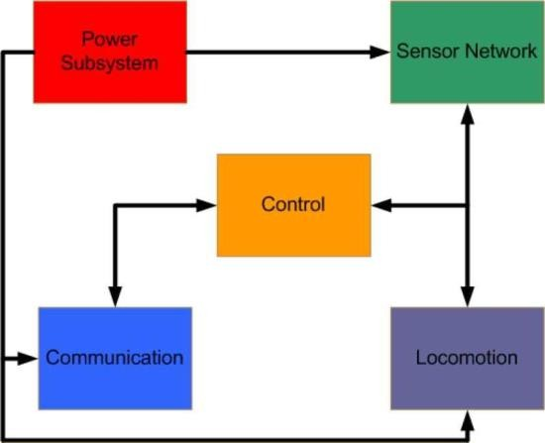

Figure 3: Block diagram showing key components of a typical robot

Hardware

Block Diagram
The hardware for the Micromouse is composed of five subsystems: Power, Sensors, Control, Communication, and Locomotion (see Figure 1). Each of the aforementioned subsystems will undergo analysis and design. It should be noted that while these systems appear independent, they are in fact very intertwined:

Sensors
Sensors give a robot the means to perceive its environment. The robot processes the information received from its sensors and reacts in a predetermined manner according to the design of the control system. For our project, the robot needs to sense the surrounding walls of the maze in order to keep track of possible routes to the center as well as dead ends, and to keep itself aligned in the center of a pathway.

To achieve its goal of traveling to the center of the maze, the Micromouse may require the sense of sight and/or touch, depending on the sensor technology (or combination of technologies) used. Sight is simulated through light and sound sensors, while touch is simulated through pressure sensors. Infrared (IR) sensors are a type of light sensor, ultrasonic or sonar sensors are a type of sound sensor, and touch or bump sensors are a type of pressure sensor. Light and sound sensors may give either proximity or distance detection. Proximity sensors only detect whether or not an object is within a predetermined range from the robot, while distance sensors determine the actual distance between the object and the robot. We first take a general look at each of these sensor technologies:

Infrared (IR) Sensors
An infrared sensor consists of an infrared transmitter that sends out an invisible beam of light into the environment and an infrared receiver that absorbs the beam of light that is reflected back (see Figure 2). The angle of the reflected beam indicates the proximity of the infrared receiver to the object that is reflecting the light. The microprocessor of the robot uses the changes in angle to measure the distance of the robot from the object ahead.
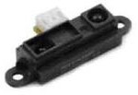
A pictA

Figure 4: Infrared sensor

Ultrasonic or Sonar Sensors
Sound, in addition to light, can be used for object detection since the speed of sound traveling through air is considerably slower than the speed of microprocessor circuits. In a sonar sensor (see Figure 3), an emitter transducer projects high-frequency sound waves outside the range of human hearing into the environment, which then bounce off possible objects ahead, and return to a receiver transducer. The time it takes for the sound wave to return to the receiver is used to determine the robot’s distance from the object.
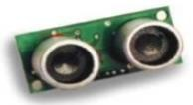
Figure 5: Ultrasonic sensor

Touch or Bump Sensors
Touch sensors operate by engaging a switch located on the fender or feeler of a robot when it is pressed or bent by an object (see Figure 4). The microcontroller processes the contact and then responds accordingly.
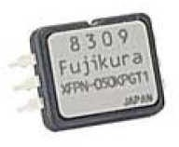
Figure 6: Touch sensor
Before deciding on a sensor technology to use for our project, it is also important to keep in mind a few additional principles. First of all, simplicity, although an extremely relative term, should be a central goal of the sensor system. We should only use the level of sensor sophistication appropriate for the project because adding too many complex sensors will not necessarily give us any more useful data. Along the same line, sensor redundancy must be handled carefully. Same sensor redundancy relies on the use of will not necessarily give us any more useful data. Along the same lines, sensor redundancy must be handled carefully. Same sensor redundancy relies on the use of two or more sensors of an identical technology, and the received data is compared to detect potential errors. On the other hand, complementary sensor redundancy relies on two or more sensors of different technologies, and the received data goes through a process of interpolation since the data from one sensor is more reliable for certain objects while the data from the other sensor is more reliable for other objects.

We now discuss the relative advantages and disadvantages of the sensor technologies discussed above. To begin, relying solely on touch sensors is clearly not a reasonable option because the robot needs to detect a wall with enough time to adjust its position and avoid crashing into the wall. Touch sensors may be included, however, to guide the robot when making precise movements such as turning.

Choosing between infrared sensors and sonar sensors is more difficult. An advantage to sonar sensors is that sound is not sensitive to objects of different colors and light-reflecting properties. However, certain materials do reflect sound better than others while some absorb sound completely. Sonar systems are extremely susceptible to electrical noise in the power circuit because of the high amplification involved. Also, there can be problems with transducer ringing. After outputting the sound wave, the transmitter transducer may have residual vibrations or ringing that false trigger the receiver transducer. A problem associated with infrared sensor technology includes the fact that the IR receiver is sensitive to ambient light. However, the frequency at which the IR beam is modulated helps to avoid interference effects from common indoor lighting sources such as fluorescent lights. Also, the effects of ambient light can be mitigated by taking two readings, one with the IR sensor’s emitter light source on and one with it off and subtracting the values to yield a more accurate measurement. Unlike sonar sensors, IR sensors are not subject to electromagnetic interference.

Finally, another advantage of infrared sensors is that they are usually somewhat less expensive than sonar sensors. Based on the discussion above, we conclude that infrared sensor technology is the most appropriate for the Micromouse. Having selected infrared sensors for the robot, we now closely examine IR sensors. An infrared proximity sensor includes an infrared emitter (the source of infrared light) and an infrared receiver (the detector of infrared light). The emitter is usually an LED made from gallium arsenide, while the receiver may be a photoresistor, photodiode, or phototransistor. The presence of light significantly alters the resistance of a photoresistor (also known as a photocell). In the dark, photoresistors have very high resistances in the 100K to 1M ohm range, while in bright light the values are several orders of magnitude lower. Unfortunately, the response time of photoresistors is somewhat slow. Photoresistors are typically cadmium sulfide (CdS) cells.

Photodiodes and phototransistors are similar in construction since both have a light-sensitive PN junction. When light strikes the PN junction, current flow begins. Photodiodes possess great light sensitivity, respond rapidly to changes in illumination, and produce a linear signal over a wide range of light levels. However, a relative advantage of phototransistors over their diode counterparts is that they can provide amplification of the light signal. Phototransistors are also superior to photoresistors because they provide a greater sensitivity to light.

We can cheaply create a proximity detector on our own by using an IR LED and one of the IR detectors mentioned above, with a minimal amount of hardware and testing. The problem with using such a proximity detector is that we can only find out whether or not a wall is within some threshold distance. We require the actual distance from the walls in order to properly correct for misalignment and smoothly steer the Micromouse through the maze. Therefore, an infrared distance sensor, which is far too complex to construct on our own, is more suited to our needs.

With the infrared distance sensors, the distance to nearby objects is measured through a process known as triangulation. First, the emitter of the unit illuminates a small spot ahead with modulated IR light. The emitter and receiver must have a shield between them, or the receiver would be flooded with light regardless of the presence of obstacles to reflect the light from the emitter. The IR light is modulated at around 40 kHz because the frequency is high enough to reduce the interference effects of common indoor light sources. The light from the illuminated spot is focused by a special lens onto the detector element, which is a charge coupled device (CCD) array, and a triangle is formed between the emitter, the spot of illumination, and the detector. Depending on the distance between the sensor module and the target surface, the angle of incidence of the reflected light will change, and the light will strike a different point along the position-sensitive detector. Thus, the location of the spot on the sensor directly corresponds to the distance from the sensor to the object ahead. The distance is output as an analog voltage, which is then sent to the microcontroller for analog-to-digital conversion and further processing.

There are a great variety of high-quality infrared sensors readily available, including those manufactured by Sharp Electronics. The following design matrix (see Table 1) compares several of the Sharp sensors, as well as one manufactured by Vishay, and a sensor unit composed of discrete parts. Based on the scores (see Table 2), a good choice is to use several of Sharp’s GP2D120 short-range infrared sensors for sensing distance to the walls of the maze. These IR sensors output a voltage relative to the distance of the sensor from an object ahead.

Table 1. Sensors

Part | Cost (£) | Interface | Range (cm) | # of external components
Sharp GP2D02 | 19.00 | Serial | 10-80 | 0
Sharp GP2D120 | 12.50 | Analog | 4-30 | 0
Sharp GP2D05 | 19.00 | Serial | 10-80 | 0
Vishay TCRT 1000 |  | Analog | 0-5 | 3+
Discrete | 3.00 | Analog | Variable | 5+

Table 2. Rating the sensors

Part | Interface | Range (cm) | # of external components | Reliability | Total
Sharp GP2D02 | 4 | 1 | 7 | 8 | 20
Sharp GP2D120 | 8 | 6 | 7 | 8 | 29
Sharp GP2D05 | 4 | 1 | 7 | 8 | 20
Vishay TCRT 1000 | 8 | 8 | 4 | 6 | 26
Discrete | 8 | 10 | 1 | 3 | 22

The final task of our design of the sensor system consists of devising a scheme for odometry, which affects both control and navigation of a robot. Theoretically, we should be able to measure the distance traveled by the robot based on the number of steps moved, a current tally of which is kept by the microcontroller. However, the stepper motor is not perfect and may miss a small percentage of steps, which would lead to an incorrect assessment of the distance traveled. Therefore, it is important to include a separate, independent means of odometry.

A very common method of odometry in robotics is through the use of a shaft encoder, which is a special sensor that measures the position or velocity of a rotating shaft. Shaft encoders are generally mounted on the output shaft of a motor. . Absolute encoders are a type of shaft encoder that measure only the position of the shaft, while incremental encoders actually measure the velocity (i.e., speed and direction) of the shaft. An incremental encoder generates a pulse train that corresponds directly to the rotational speed of the shaft, as well as direction in the case of quadrature encoders. Specifically, the output of the shaft encoder changes from low to high or vice versa whenever the shaft turns a small amount, and so the rate of the pulse varies directly with the rate of the turning shaft.
For a photo-interrupter incremental shaft encoder (also known as a beam interrupter or break beam encoder), a disk with slots cut into it is attached to the motor shaft and spins with it. A near-range infrared LED is place on one side of the disk’s slots and a phototransistor is placed on the other side. When the motor moves and the disk spins, the light from the IR LED passing through the disk is interrupted by the moving slots, and a pulse train is produced at the output of the phototransistor. The microcontroller then counts the pulses to determine how far the wheels have rotated (and thus how far the robot has traveled). The greater the number of slots, the more precise is the encoder measurement.

Another type of shaft encoder known as a photoreflector shines light from a near-range IR LED onto a striped wheel (as shown in Figure A), which then reflects the light back onto a phototransistor. The wheel is a palette of radially alternating white and black stripes that reflect and do not reflect light back to the phototransistor, respectively, which yields a pulse-train similar to that of a photointerrupter. Again, a greater number of stripes results in better resolution in the measurement.
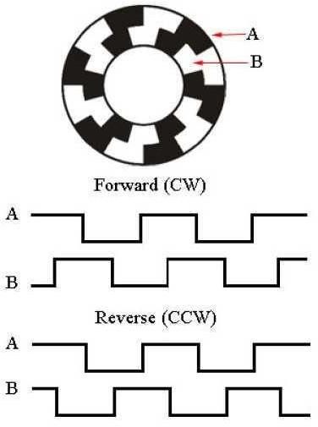

Figure 7: Photoreflector
Quadrature encoding is a very popular technique but comes with increased complexity and cost. It requires two sensors to be positioned on the striped encoder wheel so that when one sensor encounters a black and white boundary, the other sensor is exactly in the middle of a black or white stripe. The resulting pulse trains from the sensors are 90 degrees out of phase with respect to each other. By identifying the leading transition, the direction of the wheel can be determined. Looking at Figure 5, if the output of sensor B goes high to low after the output of sensor A goes high to low (or if B goes low to high after A goes low to high), then the disk is moving in the clockwise direction. Conversely, if the output of sensor B goes low to high after the output of sensor A goes high to low (or if B goes high to low after A goes low to high), then the disk is moving counterclockwise. In addition to direction sensing, a relative merit of quadrature encoding over the regular methods of shaft encoding is doubled encoder resolution. There are also non-optical approaches to odometry that have the advantage of being immune to noise from ambient light. One such method is the Hall Effect switch, which is based on magnetic principles. Other methods include the mechanical rotary encoder or the analog tachometer.

Chassis
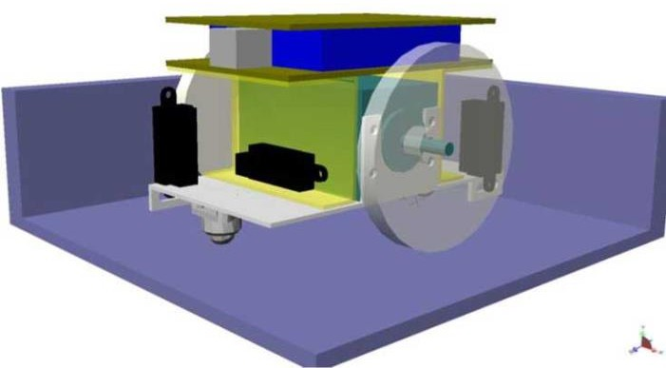
The chassis holds all the other hardware components together and provides a stable frametwork. There goals of the chassis design include making it as lightweight as possible while also making it durable and rigid. These two goals are competing, and a balance has to be established. The chassis could be made of polyvinyl chloride (PVC) plastic because it has a good weight to strength ratio (see Figure 6).

Figure 8: 3D model of chassis

Software
Flowchart: The primary purpose of the software is to maintain control over the hardware at all times and determine where to move by solving the maze (see Figure 7). Controlling the hardware consists of reading the sensors, setting the motor speed, and communicating with any external peripherals. Since each of the motor’s speeds are controlled independently, alignment corrections can be made by increasing or decreasing the speed of a single motor.

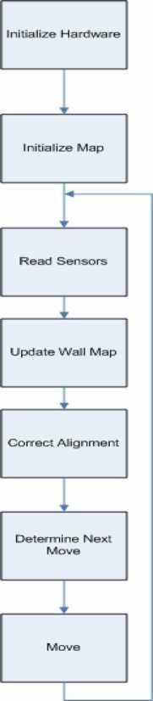
In addition to controlling the hardware, the software must also keep track of the current position within the maze and determine where to move based on the selected algorithm.
Figure 9: Flow chart
Algorithm: The principal goal of the Micromouse is to solve the maze and find its center as quickly as possible. To accomplish this task, the Micromouse uses a particular maze-searching algorithm. A vast amount of research on searching techniques already exists and is currently being undertaken. Mathematicians in the fields of topology and graph theory have been studying maze creation and maze solving algorithms for several centuries.

However, the algorithms they have developed are not feasible for Micromouse applications due to the memory and speed limitations of most Micromouse microcontrollers. Moreover, since searching through data is a fundamental function of computers, computer scientists have also devised a number of different searching techniques throughout the last few decades. Again, while these algorithms are highly effective and efficient for computers built with a sophisticated microprocessing unit, they cannot be practically implemented in the less advanced microcontrollers utilized for Micromice. As a result, Micromouse robots generally use some variation of the following three searching algorithms: Wall Following, Depth-First Search, and Flood- Fill. Wall Following is a trivial algorithm in which the mouse chooses a wall, either left or right, and then always keeps the chosen wall on its side as it moves through the maze. This algorithm is very simple to implement in code, but unfortunately it is inefficient and does not work for IEEE mazes because they are specifically designed to prevent wall-following mice from succeeding (i.e., they are not perfect mazes). For instance, the maze in Figure 8 is an example of a one in which a left wall-following mouse would end up circling the outer perimeter and never travel further into the maze. Depth-First Search is an intuitive algorithm for searching a maze in which the mouse first starts moving forward and randomly chooses a path when it comes to an intersection. If that path leads to a dead end, the mouse returns to the intersection and chooses another path. This algorithm forces the mouse to explore each possible path within the maze, and by exploring every cell, the mouse eventually finds the center. It is called “depth-first” because, if the maze is considered a spanning tree, the full depth of one branch is searched before moving onto the next branch. The relative advantage of this method is that the Micromouse always finds a route. Unfortunately, the major drawback is that the mouse does not necessarily find the shortest or quickest route, and it wastes too much time exploring the entire maze.
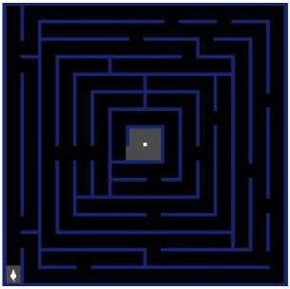
Top

Figure 10: Maze example

Flood-Fill is better suited to the Micromouse than the two algorithms discussed above. This algorithm, also known as Bellman’s algorithm, uses a sophisticated system of distance and wall information to refine a short path to the center of the maze. Since the maze has a fixed size already known to the Micromouse, namely 16 cells by 16 cells, it must first assign a value to each cell in the maze representing the distance from that cell to the center and store these values in an array. The Micromouse must also store a wall map which will be continually updated with information as the sensors detect new walls in the maze. At each cell, the Micromouse performs the following steps:
1. Check for new walls and update the wall map.
2. Re-flood the maze with new distance values and update the distance array.
3. Move to the neighboring cell with the lowest distance value.
Flood-Fill is called a breadth-first algorithm because, if the maze is considered to be a spanning tree, an entire level is searched before exploring the whole depth of a particular branch. The major advantage of the Flood-Fill algorithm is that it always finds the shortest path to the center of the maze. It is important to note that the shortest path is not necessarily the quickest path since a path filled with turns will take a longer time to traverse than one primarily composed of forward-going moves. The relative disadvantage of this algorithm is that more memory is required for execution.
Several modifications of the Flood-Fill algorithm may be implemented to increase efficiency. For example, Modified Flood-Fill is a derived version of regular Flood-Fill in which only those values which need to be changed are actually updated when searching the maze rather than re-flooding the entire maze as in regular Flood-Fill. This method is considerably faster than regular Flood-Fill because the entire maze does not need to be updated each time the Micromouse moves to a new cell. The following diagrams are a pictorial illustration of the Modified Flood-Fill algorithm:
Step 1 | Step 2
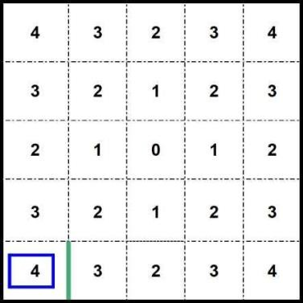 | 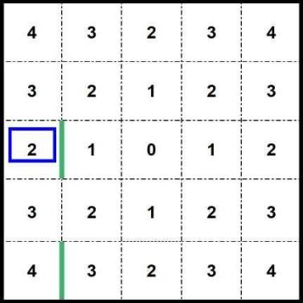
Figure 11. Step (1) Algorithm where we have a smaller version of the maze for illustration purposes. No prior wall information is known to the Micromouse. The mouse begins at the bottom left corner and sees a wall to the right and goes forward to the cell of lower distance. | Figure 12. Step (2) The Micromouse continues to follow the lowest distance number path and finds a wall to east. The neighbouring cells all have a higher number, so it must adjust its current distance number to 1 higher than lowest neighbour.
Step 3 | Step 4
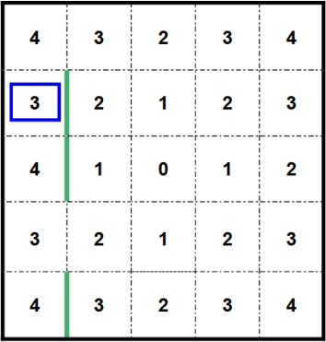 | 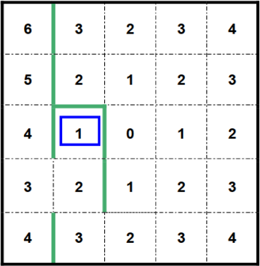
Figure 13. Step (3) The Micromouse finds another wall to the east and updates the wall map. It also re-floods the distance array with the new values. | Figure 14. Step (4): The Micromouse continues exploring up to the top left corner, updates wall and distance information as required, and then follows the lowest distance path towards the center of the maze. At its  current position, cells to south have incorrect distance information, so they must be updated.
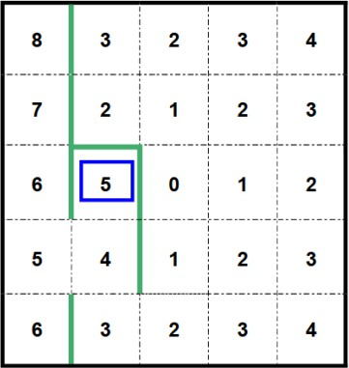 | 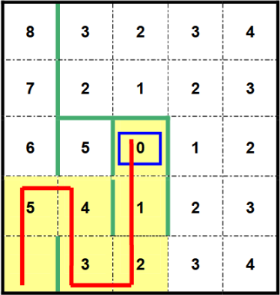
Figure 15. Step (5): In order to update the values, the distance array is changed as shown to the right. | Figure 16. Step (6): The shortest path has now been discovered. The Micromouse must simply follow number  sequence in descending order from the start to the center of the maze
Figures 11-16: Example of steps for solving the maze.

Questions to help you get started

What is a PWM timer and how does it work?
What is a PID controller and how does it work?
How does a voltage regulator differ to PID? Is it beneficial to use both in a microcontroller?
What design software will you use? CAD or Fusion 360?
Can you build a box in Fusion 360?
Can you use the Raspberry Pi PICO to make an LED flash?
Can you read and create hardware diagrams?
What sensor functionality do you require?
How will the robot detect a junction?
How will the robot turn a corner?
How does the load affect the motors?
How does the load distribution affect the manoeuvrability of the robot?
How might your robot effectively solve the maze?

Safety and ethics

Constructing a Micromouse robot is an extensive project that involves a wide expanse of electronics and controls engineering. As such, a number of varied safety and ethics issues to be considered throughout the development of the robot. Safety and ethics are in general key areas of concern for all electronics applications, but there are a number of these issues unique to the Micromouse.

With regard to personal safety, we always need to take proper precautions when handling potentially dangerous electrical equipment or other hazardous materials. While working in the laboratory, we must wear personal protective gear whenever required. For example, when soldering components onto a board, we should have safety goggles to protect our eyes, and work in a well-ventilated area to avoid ingesting excessive amounts of solder flux. It is also extremely important to wash hands thoroughly after handling soldering materials or other items that may contain lead or other toxic substances. In addition, we must be cognizant of the high voltages and currents that may be drawn by a circuit board and never touch components unless power to the circuit has been turned off. Finally, we should be aware of how to shut off power to the lab in the event of an emergency and know the location of the fire extinguisher in case a fire erupts.

Electromagnetic Interference, also known as EMI, is a disturbance that interrupts, obstructs, or otherwise degrades or limits the effective performance of electronics or electrical equipment. The design of the Micromouse has taken several measures to minimize the amount of EMI radiated. Most notably, the use of any ground loops has been strictly avoided. Instead, the grounding is replaced by a ground plane. The ground plane is a continuous plane layer on the PC Board, thus eliminating any possibilities for ground loops to exist.

A good choice for the batteries used to power the robot are Lithium Polymer (LiPo) cells. These batteries are known for their compact size and high charge density. LiPo cells also exhibit extremely high discharge rates, up to 10 coulombs. With this high discharge rate, precautions have been taken to avoid direct shorts which would cause the batteries to overheat and possibly explode. Due to the high-risk nature of the problem, two safety measures are employed. First, the design contains a fuse to prevent high current discharge. Second, the connectors on the batteries have been changed to prevent any accidental shorting.

As far as ethics are concerned, one major area of focus should be environmental responsibility. The use of lead free (Pb-free) integrated circuits (ICs) has been utilized whenever available. Lead is a naturally occurring element that is commonly used within the electronics industry to enhance soldering. Lead additives in solder help lower the melting point, reducing the risk that the semiconductor will be damaged during the soldering process. However, lead is classified as a hazardous and toxic material by the World Health Organization. Lead has been eliminated from many commercial products, in recent years, such as paint and water pipe solder. Lead has been confirmed to hamper neurological and physical development, making it most harmful to children. Since most large IC manufactures have begun offering Pb-free ICs, there is no reason not to use them in your design.

Finally, another topic related to ethics involves intellectual property rights and the issue of scholastic honesty. We must perform a great deal of research in order to complete this project. While the sharing of ideas is encouraged and necessary for the advancement of the field, proper credit must be given. In writing our report, we have to include proper references wherever we use others’ ideas or research. Also, since our project involves a considerable amount of programming, we will need to cite references if we utilize the code already developed by others.
To conclude, we mention that the discussion above is only a general synopsis of the safety and ethics concerns regarding the Micromouse. We expect many other issues to come up as we further develop our project. However, having received adequate safety and ethics training in various classes, we will be able to address these issues in a responsible manner.

Team formation

This lab includes several challenges. You will work in a small group; together you will work through all of the challenges. Time management strategies will be particularly important, as you may not have time to complete all of the challenges.

Early on, select a group leader who will help manage progress, communication, organization of meetings, preparation of minutes, etc. All group members share such responsibilities, but it may help to have an organizer. You may elect to change the group leader at a frequency of your choice. Assessed reports will be submitted via the VLE and details will be given closer to the submission date

Academic honesty

Groups should not usually be working together with each other; copying and pasting is PROHIBITED, data manipulation or any type of academic honesty violations will not be tolerated.
“All students are responsible for maintaining the highest standards of honesty and integrity in every phase of their academic careers. The penalties for academic dishonesty are severe and ignorance is not an acceptable defense. Further information on academic integrity can be found on the University website.

Appendix A: Available Resources

Rapid Prototyping Area

In addition to the Pololu 3Pi and Raspberry Pi Pico W robots provided this year you may be familiar with other hardware kits such as Arduino Nano and may wish to use these for prototyping. You may in tandem wish to consider alternative programming languages based on the experience of group members. Sometimes it is useful to get components working in one convenient environment and convert the application into your chosen environment. The choice is yours.

Traditional Engineering degrees have had an element of ‘workshop skills’ built into them – bench work using hand tools, lathe work, metal bending, welding etc. However, it is much more realistic now to expose the students to a good range of computer-aided manufacture and digital manufacturing techniques, all of which they would come across if working in industry. Below is a suggested list:
- 3D Printer
  - Makerbot Replictor Z18 RS 845-9558
  - Windows PCs for use with above equipment
- Laser Cutter
  - HPC Laser LS 6090 PRO
  - Windows PCs for use with above equipment
- CNC Router – Full Sheet
  - AXYZ.Z7
  - Windows PCs for use with above equipment
- CNC Milling Machine
  - EMCO Concept Mill 55
  - MasterCam Software – 20 Seat plus training
- CNC Lathe
  - EMCO Concept Turn 60
- Thermoforming Centre
  - Clarke 911 Thermoforming Centre
- Workbenches, Smaller Power Tools, Hand Tools and Storage, Initial Stock of Materials



Appendix B: Micromouse Competition Rules

Name of Event: Maze Solving

Robots per Event: One
Length of Event: 10 minutes maximum

Robot Weight Range: Any
Robot Dimensions: 16 cm x 16 cm
Arena Specifications: 2.88m x 2.88m
Robot Control: Autonomous
Engineering Principles: Computer Science, Artificial Intelligence, Fuzzy Logic, Electrical Engineering

Event Summary: A robot is placed in the far corner of a large, randomly drawn maze consisting of 5cm square segments. Junctions are akin to standard mazes - dead ends, T- intersections, right and left hand turns, etc. In the dead center of the maze, is an open area, 2 segments wide and 2 segments long. This central area is positioned in such a way that left-turn only or right-tun only robots can never reach it. The goal is to reach the center of the maze in the fastest time possible, across several attempts.
Here is an example set of rules for worldwide Micromouse Competitions. The following rules were adapted from the 1986 OFFICIAL RULES for the North American Micromouse contest, modified to reflect changes in technology since 1986.

- OBJECTIVE

  - In this contest the contestant or team of contestants design and build small self-contained robots (micromice) to negotiate a maze in the shortest possible time.
- RULES FOR THE MicroMouse

  - A MicroMouse shall be self-contained (no remote controls). A MicroMouse shall not use an energy source employing a combustion process.
  - A MicroMouse shall not leave any part of its body behind while negotiating the maze.

  - A MicroMouse shall not jump over, fly over, climb, scratch, cut, burn, mark, damage, or destroy the walls of the maze.
  - A MicroMouse shall not be larger either in length or in width, than 16 centimeters. The dimensions of a MicroMouse that changes its geometry during a run shall not be greater than 16 cm x 16 cm.
  - Any violation of these rules will constitute immediate disqualification from the contest and ineligibility for the associated prizes.
- RULES FOR THE MAZE

  - The maze is composed of multiples of an 18 cm x 18 cm unit square. The walls of the maze are 5 cm high and 1.2 cm thick (assume 5% tolerance for mazes). Thus, the internal navigable area within a square is 16.8cm, not 18cm. The maze comprises up to 16 x 16 unit squares, for a total maze size of up to 2.88m square. The outside wall encloses the entire maze.

  - The sides of the maze walls are white, the tops of the walls are red, and the floor is black. The maze is made of wood, finished with non-gloss paint.
WARNING: Do not assume the walls are consistently white, or that the tops of the walls are consistently red, or that the floor is consistently black. Fading may occur; parts from different mazes may be used. Do not assume the floor provides a given amount of friction. It is simply painted plywood and may be quite slick. There may be a seam between the two sheets on which any low-hanging parts of a robot may snag.

  - The start of the maze is located at one of the four corners. The start square is bounded on three sides by walls. The start line is located between the first and its second squares. That is, as the robot exits the corner square, the time starts. The destination goal is the four cells at the center of the maze. The destination square has only one entrance.
  - Small square zones (posts), each 1.2 cm x 1.2 cm, at the four corners of each unit square are called lattice points. The maze is so constituted that there is at least one wall at each lattice point.
  - Multiple paths to the destination square are allowed and are to be expected. The destination square will be positioned so that a wall-hugging robot will NOT be able to find it.
- RULES FOR THE CONTEST

  - Each contesting MicroMouse is not allocated any time to access the maze prior to their first run. Contestants have 10 minutes total to complete as many runs as they wish. Any time used to adjust a robot between runs is included in the 10 minutes. Each run (from the start cell to the center zone) in which a robot successfully reaches the destination square is given a run time. The minimum run time shall be the robot's official time. First prize goes to the robot with the shortest official time. Second prize to the next shortest, and so on.

NOTE, again, that the 10-minute timer continues even between runs. Robots that do not enter the center square will be ranked by the maximum number of cells they consecutively transverse without being touched. All robots who enter the center square within their 10 minute allotment are ranked higher than those who do not enter the center square. If a robot is in mid- run when the ten minute total time elapses, that attempt is finished and does not count. If no robots (or less that 3) finish their runs in under ten minutes, ranking will be determined by the sole discretion of the judges. Robots that do not enter the center square will be ranked by the maximum number of cells they consecutively transverse without being touched. However, judges are not required to give any rankings to robots who do not finish, and may declare no winners or declare less than 3 winners at their discretion.

Two timers are used for each contestant. One for the ten-minute total time, and a separate timer for each run within the total time.

  - The initial run shall be made from a random one of the four possible starting squares. Following runs within the 10 minutes allowed shall all be from the same starting square as the first run. The operator may abort a run at any time. If an operator touches the MicroMouse during a run, it is deemed aborted, and the robot must be removed from the maze. If a robot has already crossed the finish line, it may be removed at any time without affecting the run time of that run. If a robot is placed back in the maze for another run, a one-time penalty of 30 seconds will be added to the robot's best time.

  - After the maze is disclosed, the operator shall not feed information on the maze into the MicroMouse however, switch positions may be changed for the purpose of changing programs within the robot (changing algorithms is allowed. Entering info on the maze is not allowed and does not constitute "changing algorithms.).
  - The illumination, temperature, and humidity of the room shall be those of an ambient environment. (40 to 120 degrees F, 0% to 95% humidity, non-condensing).

BEWARE: Do not make any assumptions about the amount of sunlight, incandescent light, or fluorescent light that may be present at the contest site.
  - The run timer will start when front edge of the robot crosses the start line and stops when the front edge of the robot crosses the finish line. The start line is at the boundary between the starting unit square and the next unit square clockwise. The finish line is at the entrance to the destination square.
  - Every time the robot leaves the start square, a new run begins. If the robot has not entered the destination square, the previous run is aborted. For example, if a robot re-enters the start square (before entering the destination square) on a run, that run is aborted, and a new run will be deemed begun, with a new time that starts when the starting square is exited.

  - The robot may, after reaching the destination square, continue to navigate the maze, for as long as their total maze time allows.
  - If a robot continues to navigate the maze after reaching the destination square, the time taken will not count toward any run. Of course, the 10-minute timer continues to run. When the robot next leaves the start square, a new run will start. Thus, a robot may and should make several runs without being touched by the operator. It should make its own way back to the beginning to do so.

  - The judges reserve the right to ask the operator for an explanation of the MicroMouse. The judges also reserve the right to stop a run, declare disqualification, or give instructions as appropriate (e.g., if the structure of the maze is jeopardized by continuing operation of the robot).
  - A contestant may not feed information on the maze to the MicroMouse. Therefore, changing ROMs or downloading programs is NOT allowed once the maze is revealed. However, contestants are allowed to:

    - Change switch settings (e.g. to change algorithms (for example from left-turning to right turning - again, entering data on maze size or content is NOT inclusive of this rule.)
    - Replace batteries between runs
    - Adjust sensors

    - Change speed settings
    - Make repairs

  - However, a contestant may not alter a robot in a manner that alters its weight (e.g. removal of a bulky sensor array or switching to lighter batteries to get better speed after mapping the maze is not allowed). The judges shall arbitrate.
  - All robots, whether or not they have competed in previous contests, compete on an equal basis. All robots must be presented to the judges by the original design team, which must meet all other qualifications. First prize will go to that robot which travels from the start square to the destination square in the least amount of time. Second and third prizes will be awarded to the second and third fastest respectively.

